**Session 3 (unit-2): Function overloading and parameter passing**

1. **Overload the function “volume” for a cube, a cylinder and a cone.**

#include<iostream>

#include <cmath>

using namespace std;

int volume(int a)

{

return(a*a*a);

}

float volume(int r,int h)

{

return (3.14 * r * r * h);

}

float volume(float radius, float height)

{

return(0.33*3.14*radius*radius*height);

}

int main()

{

int a;

float radius;

float height;

int r;

int h;

cout<<"Enter side of cube:"<<endl;

cin>>a;

cout<<"Enter radius and height of a cylinder:"<<endl;

cin>>r>>h;

cout<<"Enter radius and height of cone: "<<endl;

cin>>radius>>height;

cout<<"\nVolume of cube is "<<volume(a)<<endl;

cout<<"\nVolume of Cylinder is "<<volume(r,h)<<endl;

cout<<"\nVolume of cone is "<<volume(radius, height)<<endl;

}

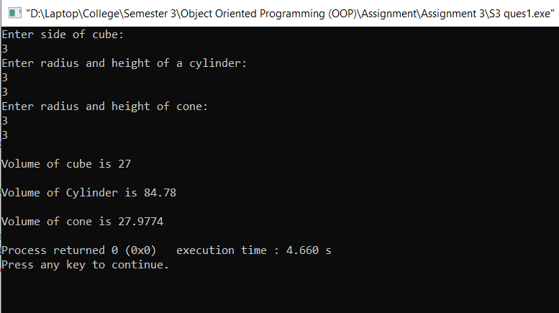

1. **WAP to show swapping of two numbers by :**

**a) Call by value.**

#include<iostream>

using namespace std;

int main()

{

int a, b;

a = 10;

b = 40;

cout << "(a,b) = (" << a << ", " << b << ")\n";

swap(a, b);

cout << "(a,b) = (" << a << ", " << b << ")\n";

}

void swap(int x, int y)

{

int temp;

temp = x;

x = y;

y = temp;

}

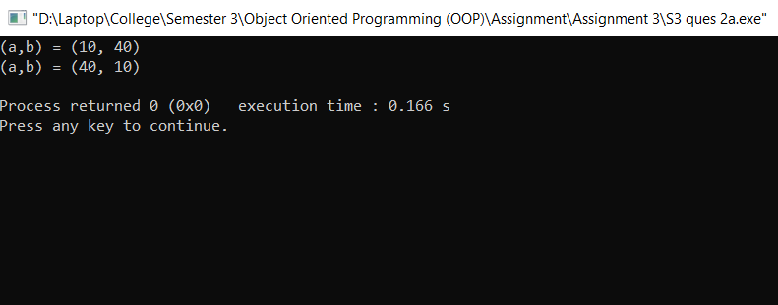

b) Call by address (pointers)

#include<iostream>

using namespace std;

void swap(int *x, int *y)

{

int temp;

temp = *x;

*x = *y;

*y = temp;

}

int main()

{

int a, b;

a = 10;

b = 40;

cout << "(a,b) = (" << a << ", " << b << ")\n";

swap(&a, &b);

cout << "(a,b) = (" << a << ", " << b << ")\n";

}

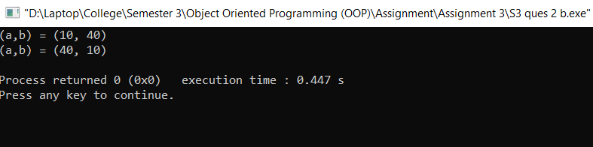

c) Call by address (reference)

#include<iostream>

using namespace std;

void swap(int &x, int &y)

{

int temp;

temp = x;

x = y;

y = temp;

}

int main()

{

int a, b;

a = 10;

b = 40;

cout << "(a,b) = (" << a << ", " << b << ")\n";

swap(a, b);

cout << "(a,b) = (" << a << ", " << b << ")\n";

}

